Feature Importance in Random Forest:

For example, we have this tree
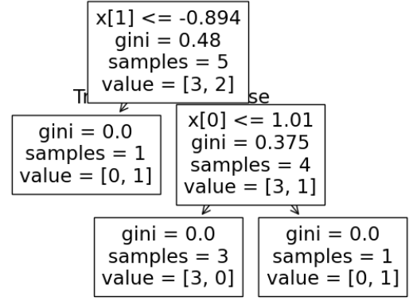
It has two columns and X[1] and X[0]
So first we will find the importance of the node ni
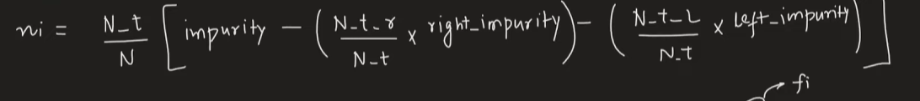
N_t/N_t_l/N_t_r = no of samples and same for left and right
N = no of rows in dataset
Node importance of X[1]:
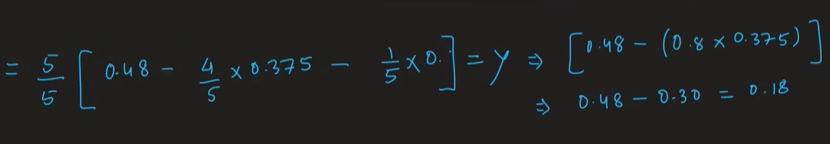

Node importance of X[0]:
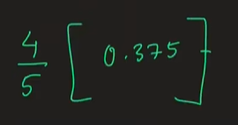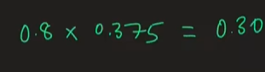

Now we will calculate 0th and 1st feature importance by this formula:
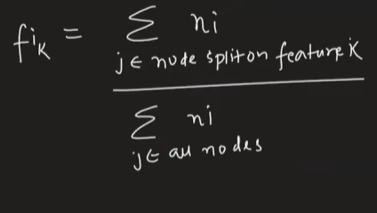
For our tree it will go like:
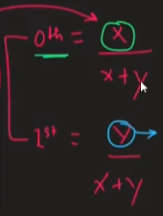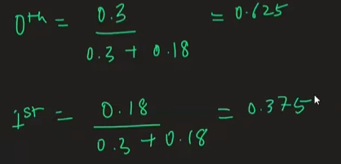

Same as we get from the code:
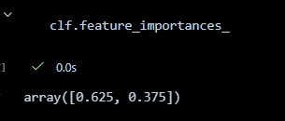

Taking another example:
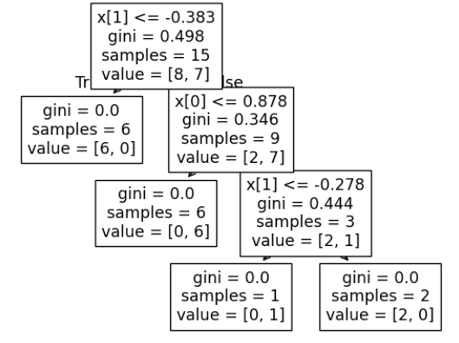
Here we got three nodes:
2 for 0th column and 1 for 1st column.
Node importance of three nodes:
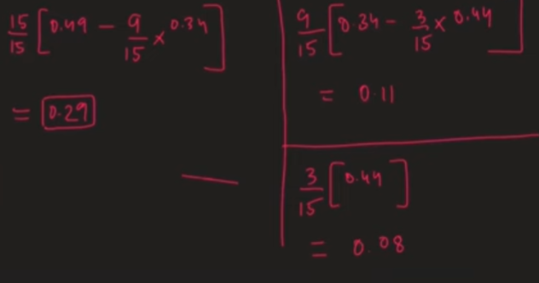

Feature importance of 0th:
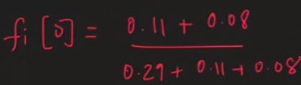
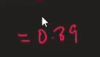

Feature importance of 1st:
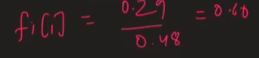

In this the process is that the decision tree finds out feature importance and random forest average out the feature importance from all trees

